-
1. INTRODUCTION

Our project predicts the value of the 'play' attribute in the 'weather' dataset. The 'play' attribute holds the value 'yes' when it is favourable to go outside and play , otherwise it holds the value 'no'. Our project uses the J48 classifier of the WEKA library to build a decision tree and predict the values of the 'play' attribute of the dataset. We use the method of 10 cross split validation for training our model and further calculate the accuracy of the built model. Finally we label the unknown instances using the model and also display the decision tree that we used for classification.
2. LITERATURE SURVEY
We referred to several textbooks for getting aquainted with the basic concepts of machine learning as quoted in our references page. Along with the textbooks we also found some code snippets on http://www.programcreek.com/ very helpful. In addition to these we also referred to http://weka.wikispaces.com/ for understanding the Weka library and how to use Weka with java.After referring to these all resources we got familiar with the basic terms and concepts of machine learning along with the Weka library and how to use it with java. The extract of our study for the project is given below:
MACHINE LEARNING: Machine learning is a scientific discipline that deals with the construction and study of algorithms that can learn from data. Such algorithms operate by building a model based on inputs and using that to make predictions or decisions, rather than following only explicitly programmed instructions. There are many real world examples of machine learning like pattern recognition,biometric verification,speech recognition etc. There are different types of machine learning.
1.Classification: Classifying different objects into certain classes they belong to.It is also known as supervised learning because the classes are known ahead of time.
2.Clustering: This is unsupervised learning because the size and shape of clusters is not known to us.
3.Recommendation: Recommend a value for an item on the basis of past behaviour of things related to it.
Inorder to implement machine learning using a programming language the first thing we need is a dataset containg objects and their attributes.Then we need to write a function or code which will train and learn from the dataset and certain algorithms included in the libraries.
The function separates our data into training data ad test data which is called as split cross validation method. Once a good number of training data is fed to our function it then takes as input a new set of data called as future data or unseen data and tries to predict or approximate.
The prediction or appoximation is not ideal ofcourse.It includes errors and the calculation of this error is also a fundamental process in machine learning.Error is calculated using error function or loss function.
Dataset:A set of instances with different values of all the attributes for the instances . Generally, no ordering on instances is assumed. Most machine learning algorithms use ARFF (attribute relation file format)format.
Training data: The part of the dataset used for training the classifier.
Testing data: The part of the dataset used for testing the classifier.
Attributes/features: the properties of an object from a given dataset.
Label:It is a special attribute which denotes the objects class.
Accuracy:The rate of correct (incorrect) predictions made by the model over a data set (cf. coverage). Accuracy is usually estimated by using an independent test set that was not used at any time during the learning process. More complex accuracy estimation techniques, such as cross-validation and the bootstrap, are commonly used, especially with data sets containing a small number of instances.
Classifier: A classifier is the implementation of a machine learning algorithms which is learned by the machine using the training data fed from a given dataset.
Cross-validation:A method for estimating the accuracy (or error) of an inducer by dividing the data into k mutually exclusive subsets (the ``folds'') of approximately equal size. The inducer is trained and tested k times. Each time it is trained on the data set minus a fold and tested on that fold. The accuracy estimate is the average accuracy for the k folds.
WEKA:Weka stands for Waikato Environment for Knowledge analysis.It is a library for machine learning which contains many algorithms and classes which are very essential and helpful in writing machine learning functions.It has to the ability to process datasets in the proper format required.
The below given block diagram shows all the different components of a machine learning system and how the whole thing works.

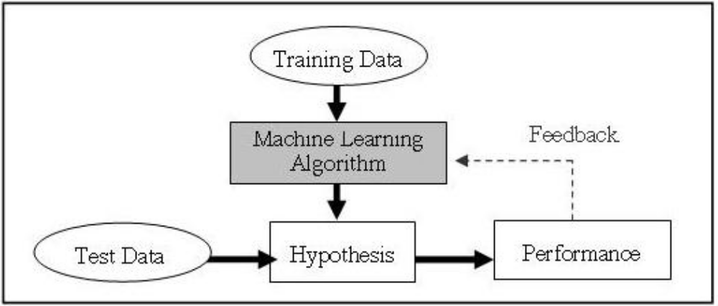
Fig 2.1 Block Diagram for a machine learning model
3. SYSTEM DESIGN
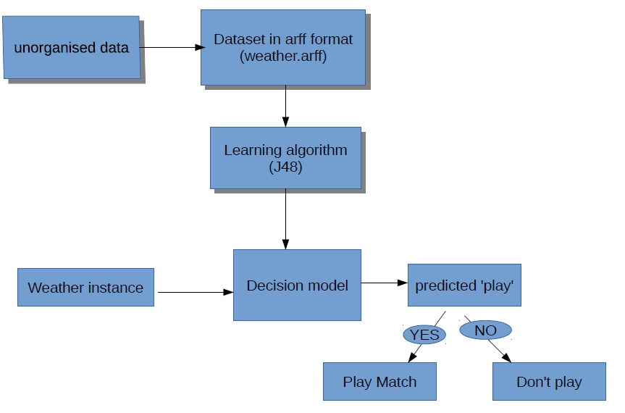
Fig 3.1 Flowchart of the predicting model

The dataset collected is usually in unorganised form and is converted to arff format.This data is our trianing data which is then passed to the J48 classifier which builds a decision tree(model) based on this training data.Now, when the testing data consisting of one or more weather instance for which the value of play weather attribute is unknown is passed to this decison model, the classifier predicts those unknown values as either "yes" or "no".

4. IMPLEMENTATION

5. RESULTS
The decision tree was built using the training data set. The values for the play attribute were succesfully predicted for each instance in the testing dataset according to the decision tree built.Thereafter, the accuracy of the prediction was calculated.

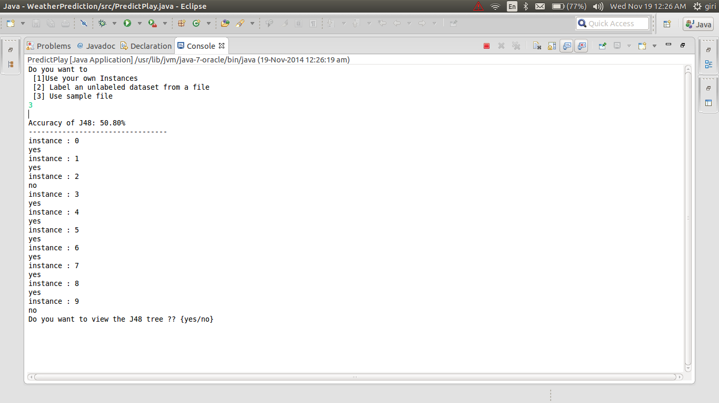
Fig 5.1 Predicted values
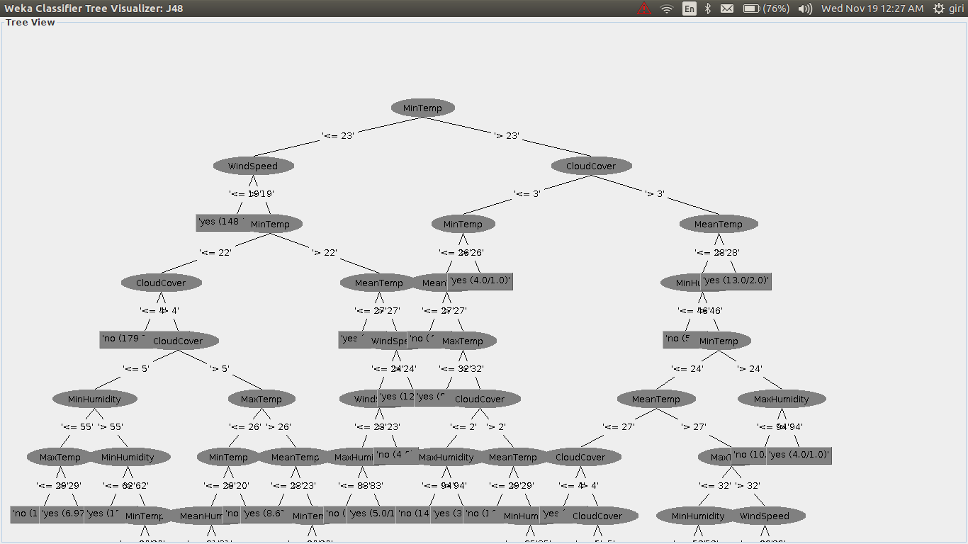
Fig 5.2 Decision Tree

7. CONCLUSION
We concluded that using the concepts of machine learning one could easily predict values for a given attribute in a dataset if the values for the other attributes are known. These prediction values could be further used for other purposes for e.g in our case the value of the play attribute could be used to decide whether a cricket match should be held in a particular city on a particular day or not given we have the weather data for that city.

6. FUTURE ENHANCEMENTS
We aim to extend our project by collecting other datasets like data of diabetic patients ,heart patients and predict the attributes in those datasets by applying those concepts which we have learnt from this project. And also doing other types of classifications like multiclass classification etc. We also aim to extend project to some basic concepts of data mining and artificial intelligence, if possible.

8. REFERENCES
[1]" Introduction to Weka" , https://www.cs.auckland.ac.nz/courses/compsci367s1c/tutorials/Introduct-
ionToWeka.pdf

[2] Zdravko Markov, "An Introduction to the WEKA Data Mining System", http://www.cs.ccsu.edu/~markov/weka-tutorial.pdf
[3]"Hello World program in WEKA " , http://www.programcreek.com/2013/01/a-simple-machine-learning-example-in-java/
[4] "Using WEKA in Java code" , http://weka.wikispaces.com/Use+WEKA+in+your+Java+code
[5] Ian H. Witten and Eibe Frank on "Introduction to Machine Learning", Data MIning :Practical Machine Learning

